365 Tenant Lab for SC 300 Preparation
- Created Office 365 E5 free trial tenant
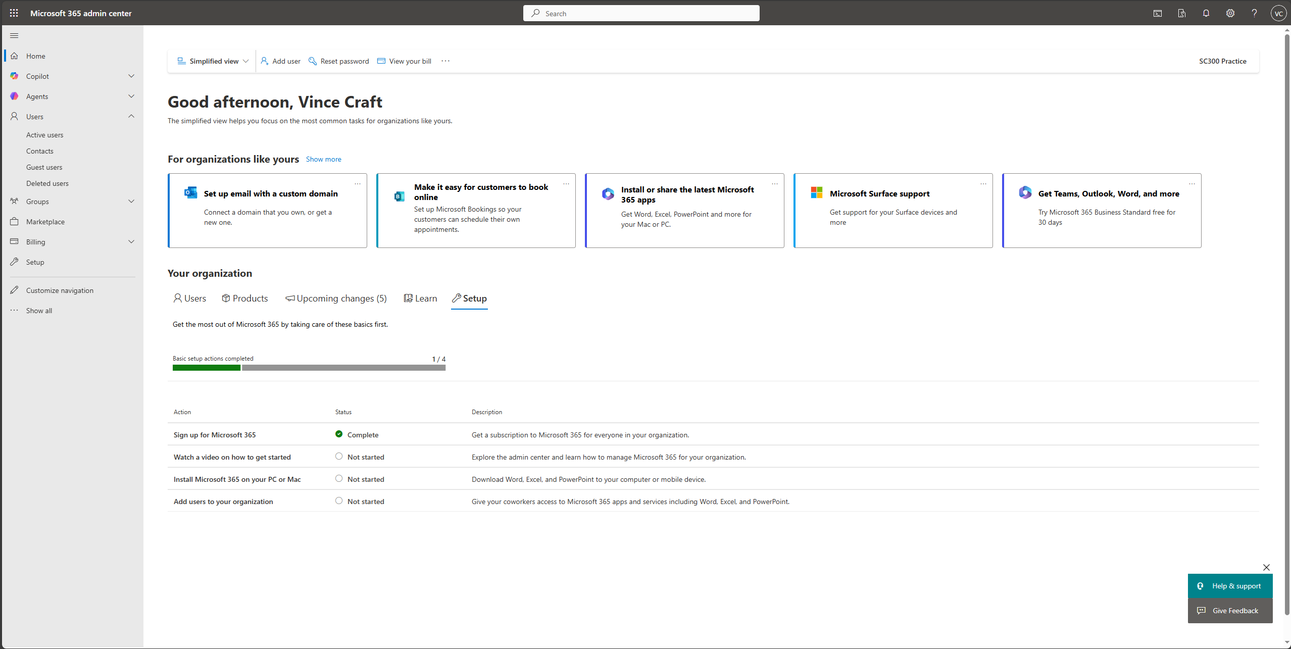
- Started Free Trial for Microsoft 365 E5 license
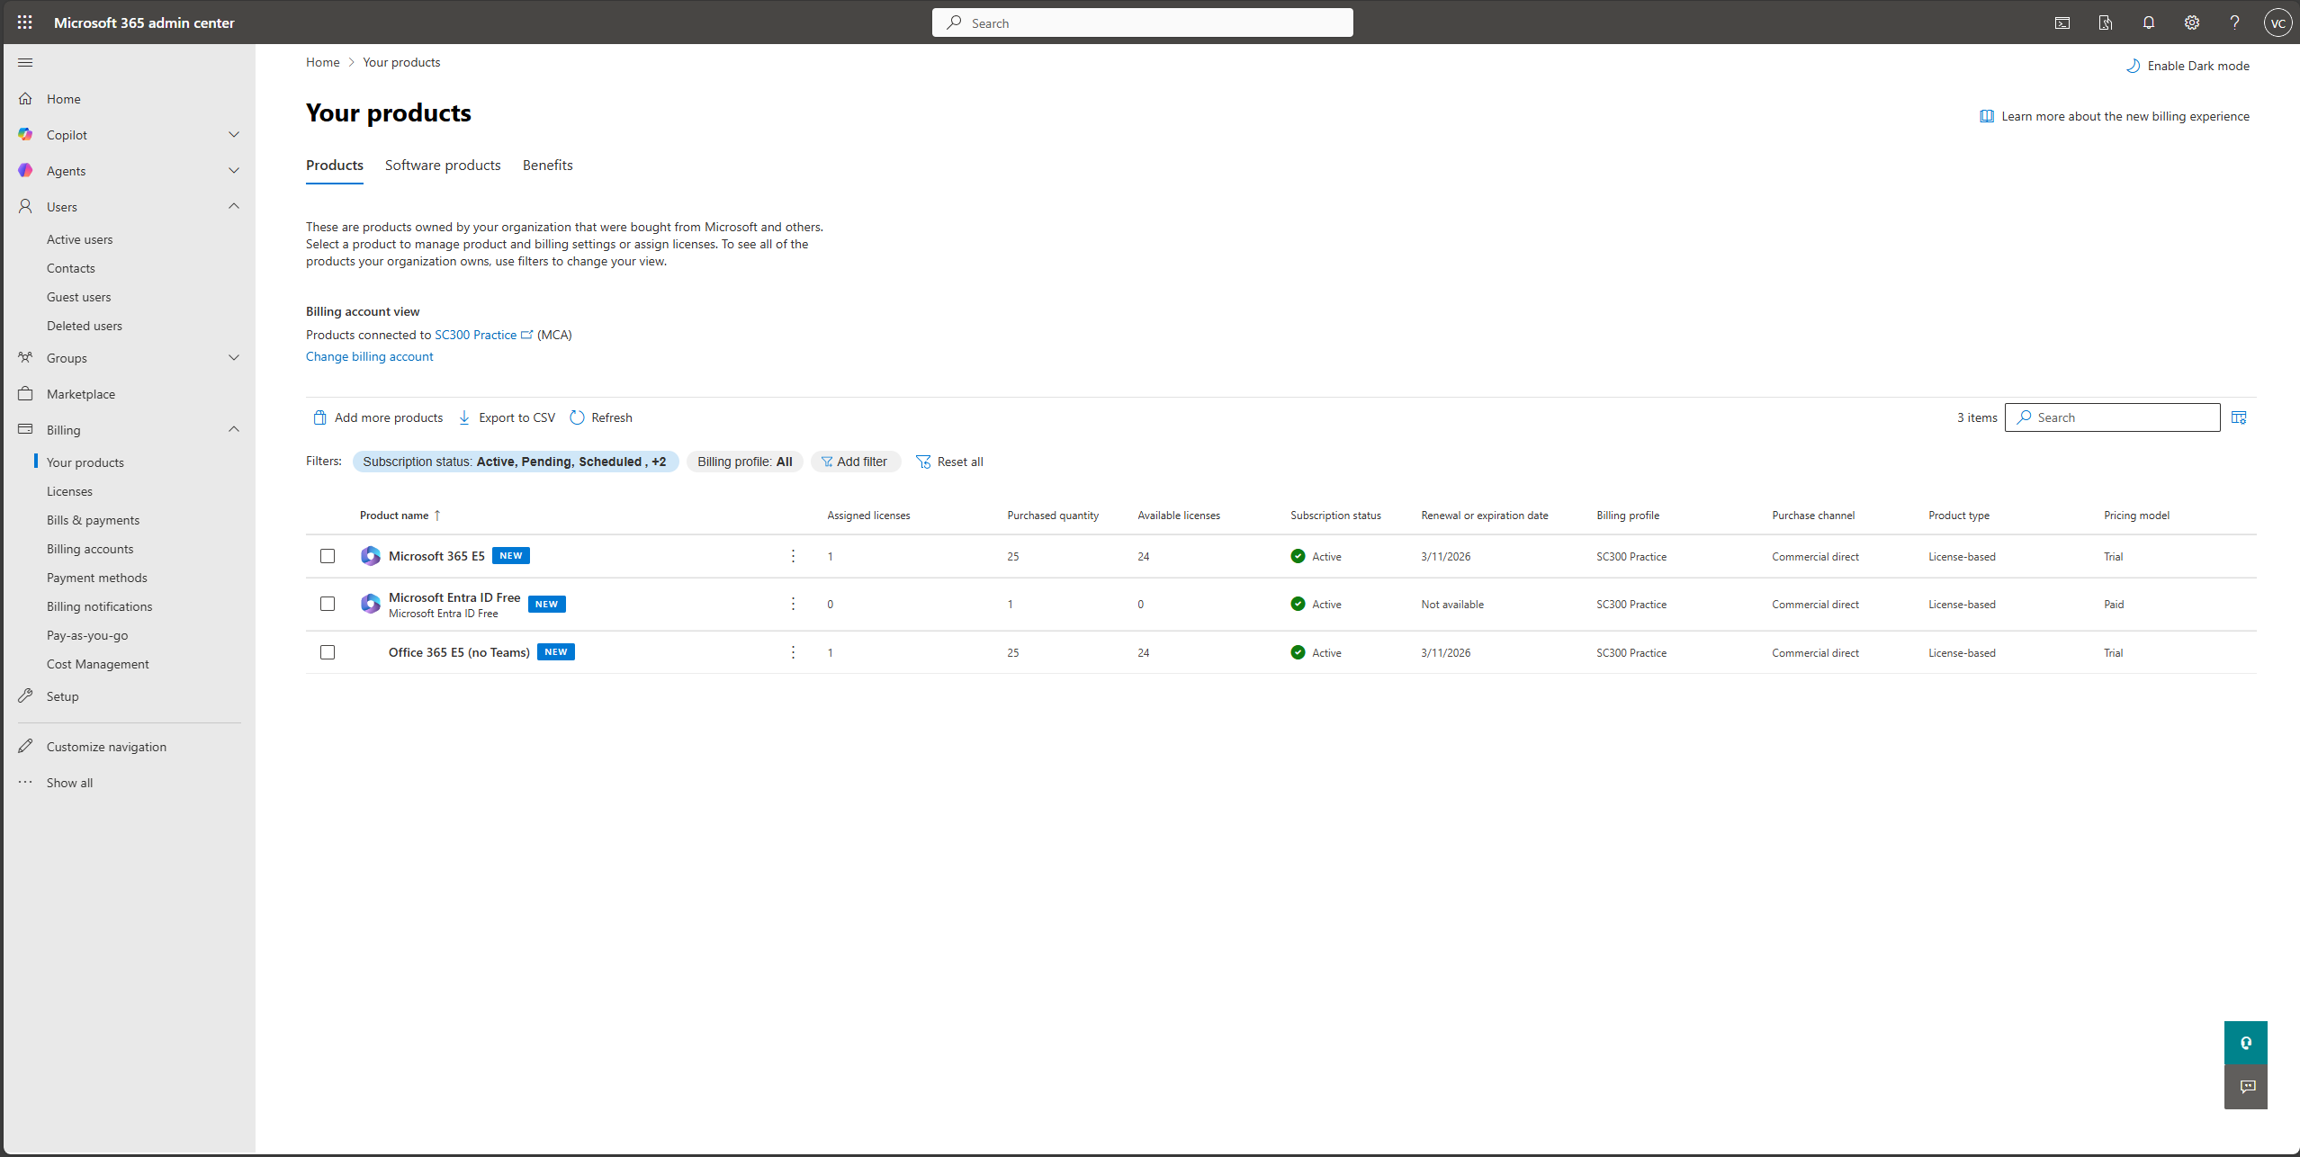

- Creating a new user
